Accessibility ID Report — carRentalSmart
Date: 28.06.2026 20:37 | Platform: ANDROID

Element ID | Page | Type | Label / Text | Value | Resource ID | Status | New Status | AI Suggestion
carRentalSmart_element_1 | SearchActivity | ImageView |  |  | facet_entry_point_item_icon | Duplicate ID | ID Must Be Added (Waiting Dev) | imageview_icon
carRentalSmart_element_2 | SearchActivity | TextView | Car rental | Car rental | facet_entry_point_item_label | Duplicate ID | ID Must Be Added (Waiting Dev) | car_rental_label
carRentalSmart_element_3 | SearchActivity | Button | Enter a pick-up location |  |  | Missing ID | ID Must Be Added (Waiting Dev) | enter_a_pick_up_location_btn

📸 Screenshot
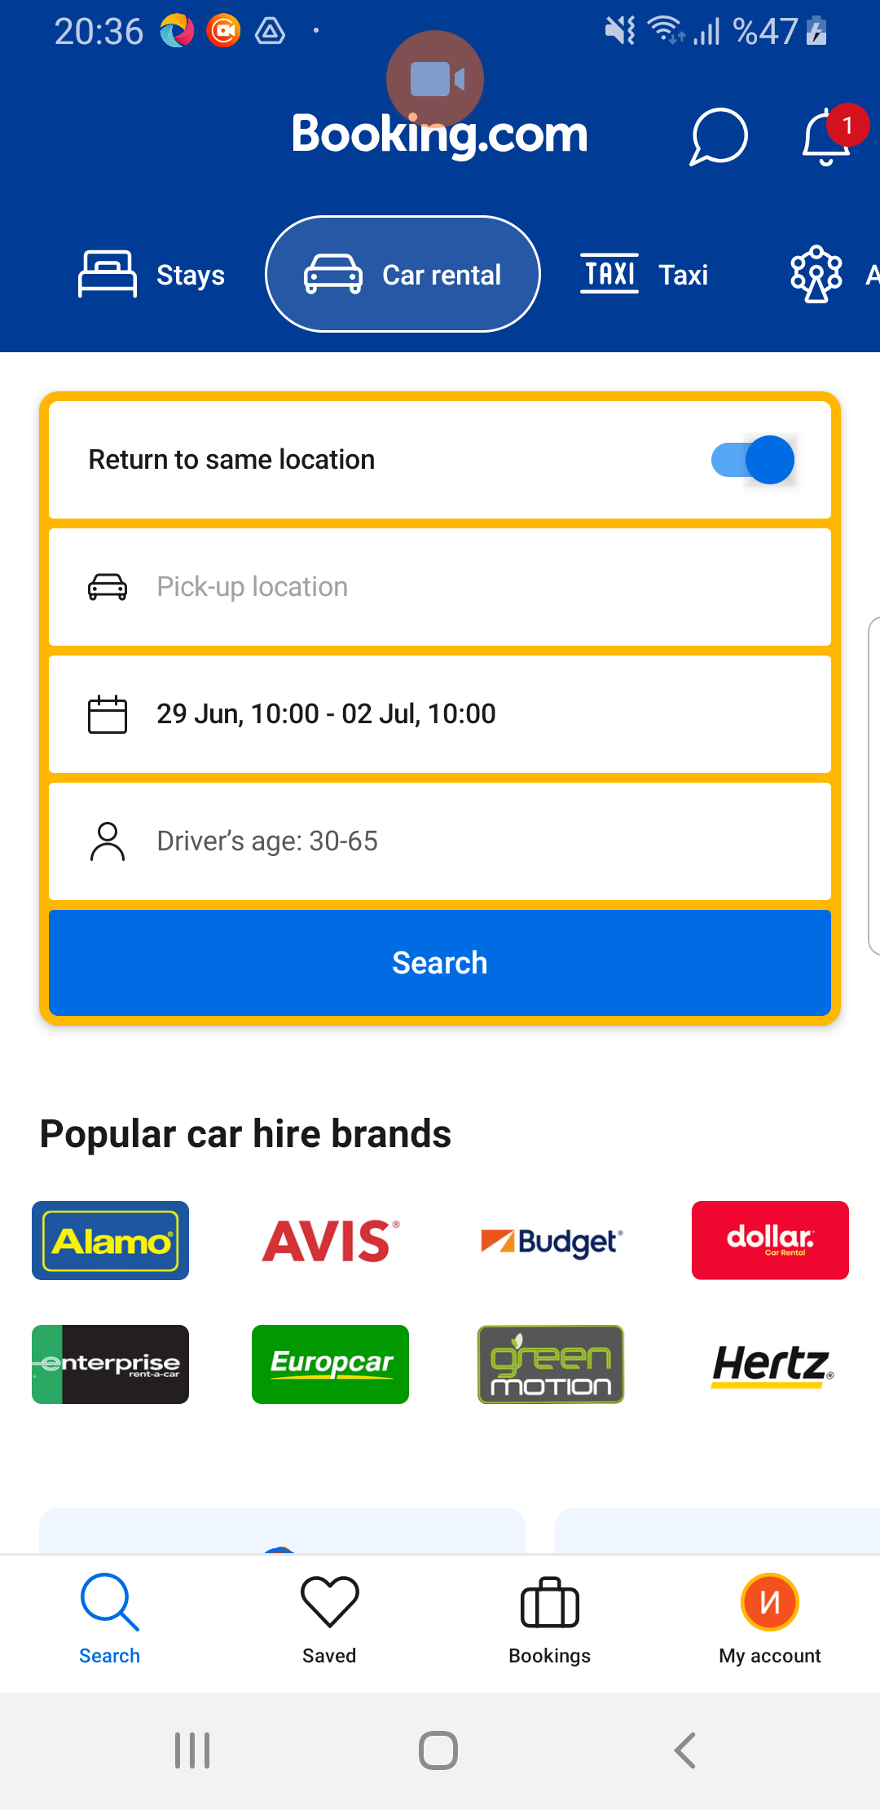
carRentalSmart page screenshot

